

**PROJECT DELIVERABLE 1**

**GROUP MEMBERS:**

|  |  |
| --- | --- |
| **NAME** | **ROLL NUMBER** |
| HAIDER ARSHAD | 20I-2379 |
| SHERAZ TARIQ | 21I-1188 |

**TITLE:**

*“TRIP BRIGHT”*

**PRIMARY PERSONA:**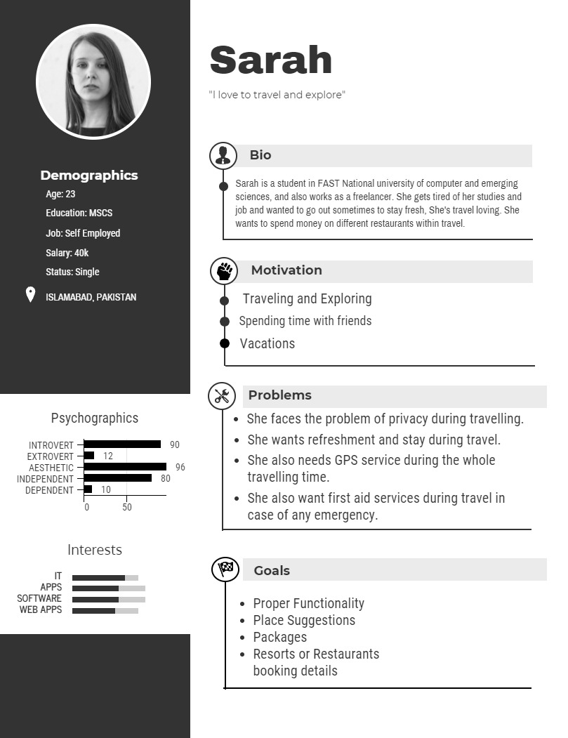

**Feature List (primary persona):**

**Problems:**

* She faces the problem of privacy during travelling.
* She wants refreshment and stay during travel.
* She also needs GPS service during the whole
* travelling time.
* She also wants first aid services during travel in
* case of any emergency.

**Wants:**

* She wants an app which is easy to use and have proper functionality in it.
* She wants to make quick selection without asking anyone, through app.
* She also wants a place suggestion feature in the app so that she can choose the place easily.
* She also wants to book resorts or restaurants from app.
* She also wants to know booking details of restaurants and hotels.

**Wishes:**

* She wants an AI-Based app which learns her personality and show results accordingly.
* She wants interface which is easy to use and user-friendly.

**SECONDARY PERSONA:**

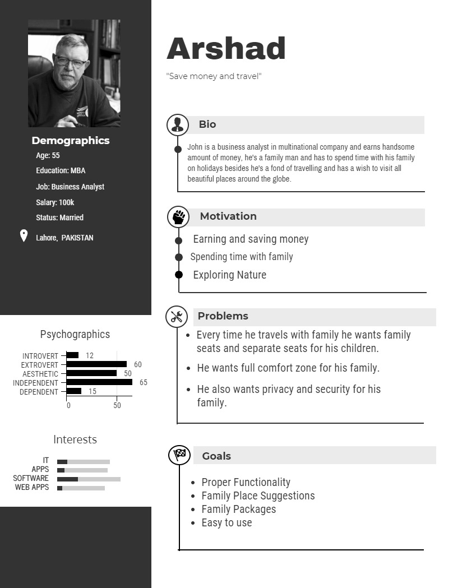

**Feature List (secondary persona):**

**Problems:**

* Every time he travels with family he wants family
* seats and separate seats for his children.
* He wants full comfort zone for his family.
* He also wants privacy and security for his
* family.

**Wants**:

* He wants proper functionality in the app with an easy interface.
* He wants the app to give suggestions of Family Places so that he can take his family for the vacations with him.
* He wants the system to give family packages which are suitable and affordable for his family.

**Wishes:**

* He wishes to perform any task in minimum and easy steps so that he can easily confirm his tours without any difficulty.
* He wishes to have special discounts for his family.

**Feature List (Overall):**

**Wants:**

* Easy to use
* Quick Selection
* Place suggestions
* Resorts Bookings
* Details of Restaurants
* Proper Functionality
* Suggestion of family Places
* Family Packages and deals

**Wishes**

* AI-Based application
* Special discounts for family deals.
* Preferred minimum number of steps.

**Methods used to dig-out information**

*Interview session*

Screenshot of the session:

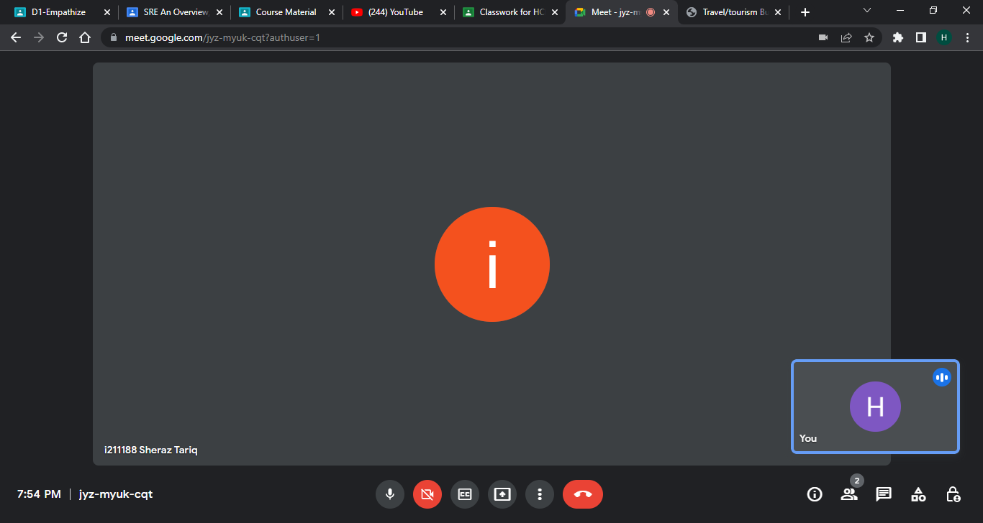

**Question:** On what type of platform, you want your app to run?

**Answer:** I want a mobile app.

**Question:** What are the main features you want?

**Answer:** I can see different travel plans and book them according to my budget.

**Question:** Do you want a GPS system in the app?

**Answer:** Yes, I want a GPS system.

**Question:** What do you want about your data?

**Answer:** I want my data to be secured. No third-party apps should have access to any of my data.

**Question:** Do you only want local tours?

**Answer:** I want local as well as international tours.

**Question:** Do you want a local guide?

**Answer:** Yes, I want a guide who can guide me to different places I do not know about.

**Question:** What do you want about hotel booking?

**Answer:** I want a list of hotels along with their budget and menu.

**Question:** Do you want a tour journal?

**Answer:** Yes, I want a tour journal. In case if the guide is not available, tour journal can help me out.

**Question:** What do you want about maps and routes?

**Answer:** I want google maps and all possible routes for my destination.